Energy and the Ecosystem

Feeding relationships – Producers, Consumers and Decomposers

- The essence of survival of organisms is their activity.

- To carry out these activities, organisms need energy.

- The immediate source of energy in cells is the molecule ATP (adenosine triphosphate) which is produced by respiration.

- The only input of energy on Earth is sunlight, which is absorbed by plants and converted into sugar.

- The energy ATP represents has been transferred from sugar and other organic molecules, the respiratory substrates.

- These organic molecules are obtained from nutrients as a result of the organism’s mode of nutrition.

- Some organisms can use chemicals to produce energy. This is called chemosynthesis.

Movement of Energy

- There are two main types of organisms. They are autotrophs and heterotrophs.

Define:

Autotrophs
________________________________________________________________________________________________________________________________________________

Heterotrophs
________________________________________________________________________________________________________________________________________________

- There are three types of consumers:

- Herbivores – feed exclusively and directly on plants and plant material. Herbivores are primary consumers.

- Carnivores – feed exclusively on other animals. Carnivores that feed on primary consumers (herbivores) are called secondary consumers. Carnivores that feed on secondary consumers are called tertiary consumers, and so on.

- Omnivores – feed on both plant and animal matter. Therefore, they are a blending of a consumer. An example would be a black bear.

Eventually, all producers and consumers die and decay.

- Organisms that feed on dead plants and animals, and on the waste matter of animals are called ________________. These organisms are essential for the breakdown of organic molecules to their smallest form.

Define:
Detrivore
________________________________________________________________________________________________________________________________________________

Saprotroph
________________________________________________________________________________________________________________________________________________

Answer the following on a piece of paper in your notes.

Apply one or more of the terms below to describe each of the listed features of a freshwater lake.

population ecosystem habitat abiotic factor community biomass

- The whole lake
- All the frogs in the lake
- The flow of water through the lake
- All the plants and animals present
- The total mass of vegetation growing in the lake
- The mud of the lake
7. The temperature variations of the lake
Trophic Levels, the Food Chain and Food Webs

- The feeding relationship in which a carnivore eats a herbivore, which itself has eaten plant matter, is called a food chain.

- Energy from the sun is the initial energy source. The arrows go from producers to consumers to represent the energy flow. Depending on the ecosystem, the food chains are different.

- There are two types of food chains:

  - Grazer food chain – a producer that is fed on by a herbivore, who is in turn eaten by a carnivore.

  - Detritus food chain – food for decomposers come from plant and animal waste and remains. This is where scavengers are located.

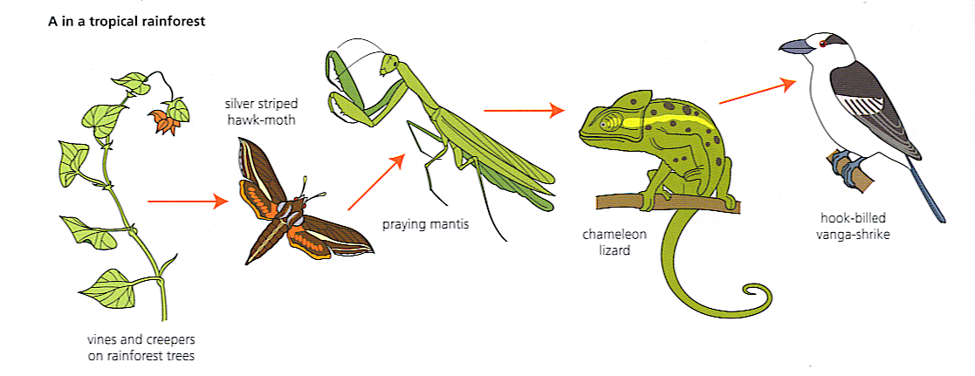
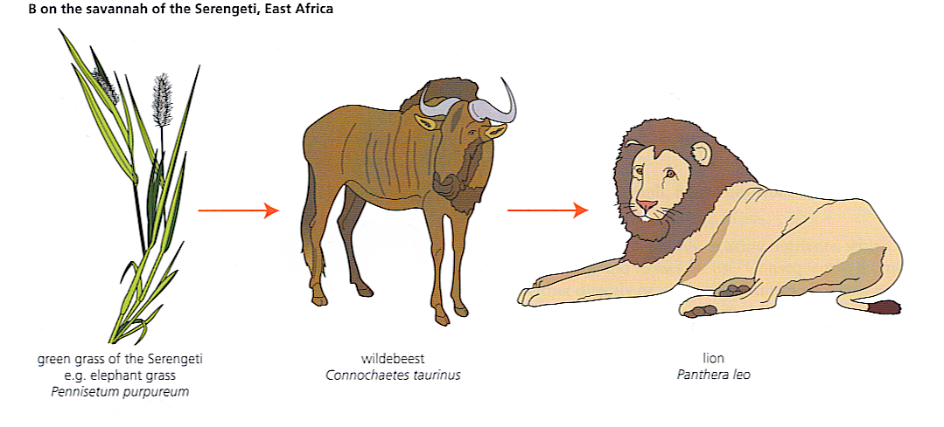
In an ecosystem, food chains are not isolated. They interconnect with one another, as a predator may have several species of prey, or a primary consumer that eats several species of plants. This is called a food web.

- Food webs are advantageous as they allow predators and prey alternative food choices when one source becomes scarce. It also allows the consumers to take full advantage of some food sources when they become plentiful as well.

Define

Trophic Levels
________________________________________________________________________________________________________________________________________________

For example, if it is a producer, it is the first trophic level. Plants are said to belong to the first trophic level since the chemical energy they store and use is one step from the original energy source, the sun. When an organism eats another, it is one step further removed, or one trophic level up.

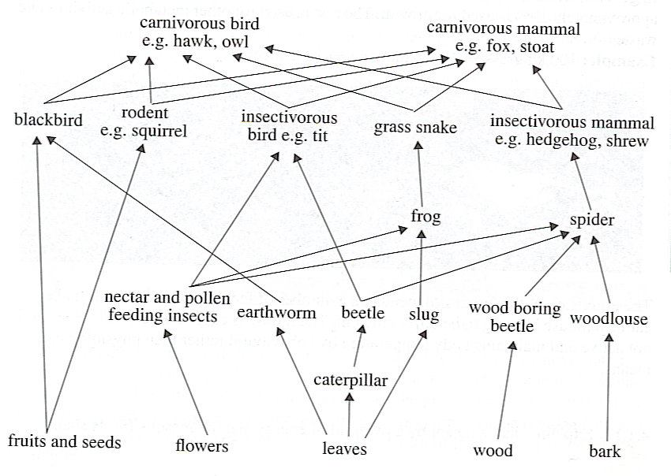
For example:

- To look at trophic levels, it is easier to isolate a food chain, and then determine the trophic levels.

- Note that there is not a fixed number of trophic levels to a food chain, but there are usually three to five levels only.

- Also important, is that food chains tell us about the feeding relationships of organisms in an ecosystem, but they are entirely qualitative relationships rather than providing quantitative data (numbers of organisms).

Using the information on the food webs, identify the trophic levels for each of the organisms in an isolated food chain. Do this by constructing individual food chains from each ecosystem. Identify each organism with its common name and state whether each is a producer, primary consumer, secondary consumer, etc.

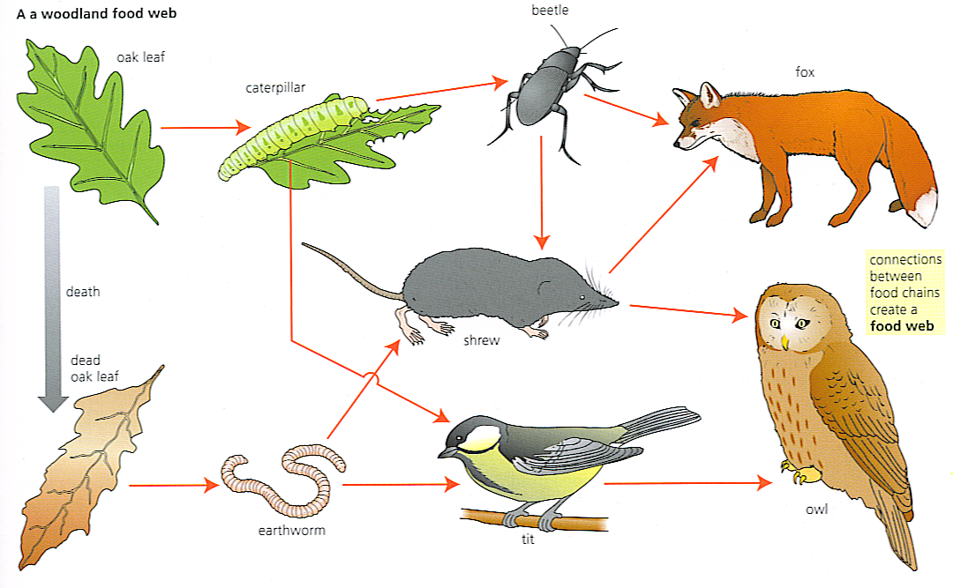
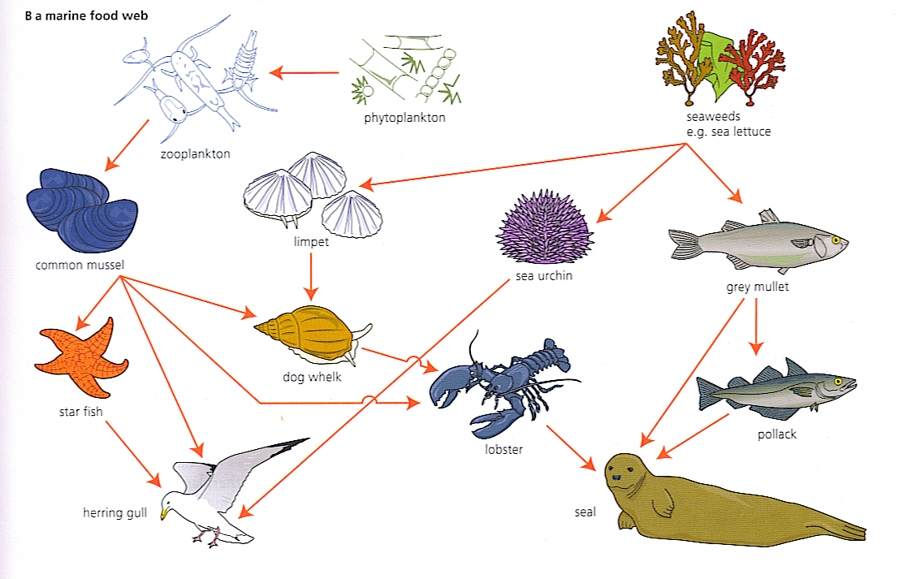
Problems with Food Webs – The Flow of Energy

Light is the initial source for almost all communities. While materials cycle through the ecosystem, energy enters with autotrophs and is used or changed into other forms of energy and leave the ecosystem again.

The problem is that every time energy is transferred from one level to another, some is lost, mostly as heat.

Much of the light energy is not retained in a green leaf. Some is reflected, some transmitted, and some lost as heat energy. Heat is also a waste product of the reactions of respiration and of the plant’s metabolism, as sugar is converted into lipids and amino acids. Some of the metabolites are used in the growth and development of the plant, and by these reactions energy is locked up in the organic molecules of the plant body. When the plant is eaten, the stored energy is passed on to the consumer. When the plant dies, the remaining energy passes on to the detritivores and decomposers. When the consumer eats the producer, the energy is passed on. The consumer transfers some of the energy into muscular movements and to maintain its metabolism. Some remains undigested and goes through the consumer unchanged. If the consumer is caught and eaten by another consumer, the energy is again transferred.
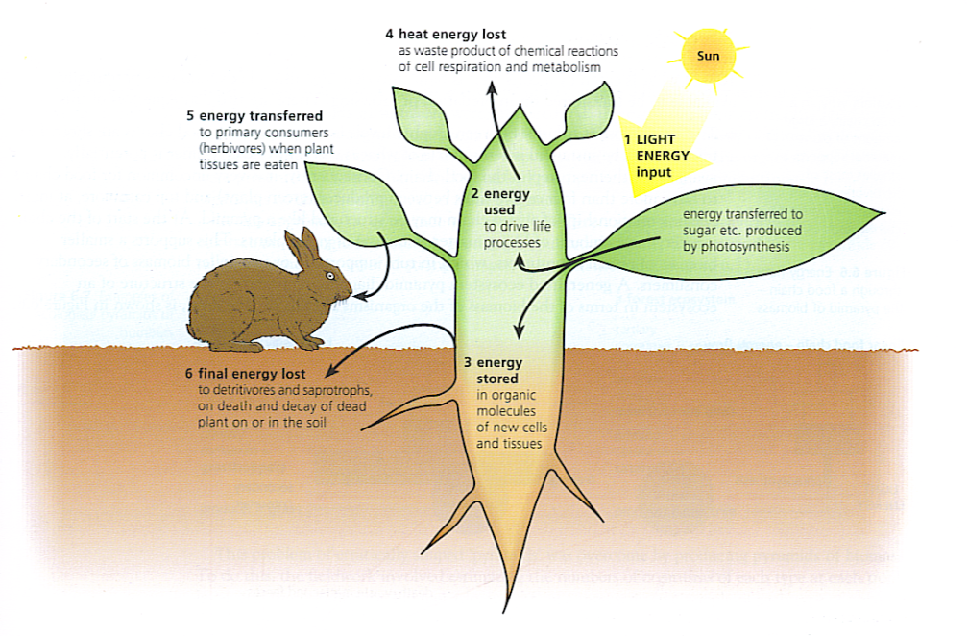
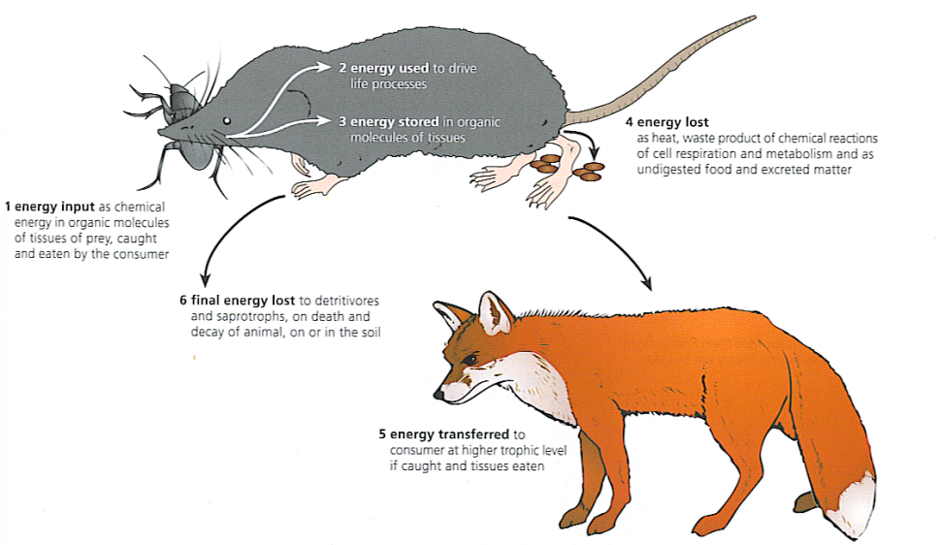
In general, the higher the trophic level, the more food you must consume to maintain a desired level of energy. Only 10% - 20% of what is eaten by a consumer is built into the body of an organism to be potentially available for a predator or browsing. There are two consequences of this:

- The energy loss at transfer between trophic levels is the reason why food chains are short. Few transfers can be sustained when so little of what is eaten by one consumer is potentially available to the next step in the food chain. That is why most food chains have 5 levels at the most.
- Feeding relationships of a food chain may be structured like a pyramid. At the start of the chain is a very large amount of living matter (biomass) of green plants. This supports a smaller biomass of primary consumers, which in turn supports and even smaller biomass of primary consumer, which in turn supports and even smaller biomass of secondary consumers.

In other words, there is a huge loss of energy at each stage and an ecosystem can only support a limited number of higher trophic level organisms.

For example:

Only 1.2% of sunlight is used for photosynthesis, a loss of 98.8%. Of the 1.2 %, a deer only will get 16.2 % of the energy out of plants. Of this energy, a wolf only gets 11.4% of useful energy from the deer.
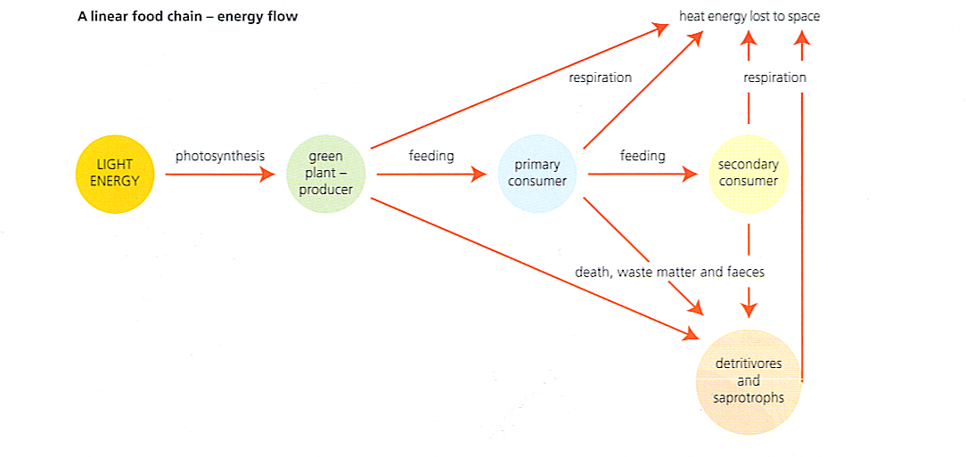
Ecological Pyramids

Ecological pyramids are practical means of analysing ecosystems. They can be used to express seasonal changes in one ecosystem or to compare different ecosystems at comparable times.

Initially, pyramids of numbers were produced. All the organisms at each trophic level were counted. The results were presented as rectangular blocks, stacked on top of each other, representing the numbers of organisms at each trophic level in a bar diagram. The organisms can be observed and not damaged with this approach.

The problem with this approach was that it did not allow for differences in size of organisms. Also, some organisms are so numerous it was hard to make the levels of the pyramid. A giant oak tree and single green algae are counted the same. Consequently, the pyramids of numbers created strange shapes of limited meaning.
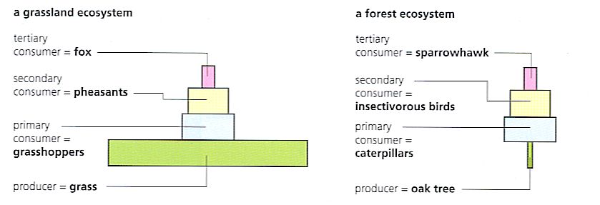
To overcome this, is to produce pyramids of biomass. To find biomass, the numbers of organisms or each type in a trophic level are estimated and then the dry weight of the organisms is found by using a sample of a representative size. A pyramid of biomass will have a shape close to the ideal model. Based upon seasonal changes or the amount of nutrients available at each trophic level, the pyramid can change shape. The problem with a pyramid of biomass is the organism is destroyed to find its dry mass. More mass is on the bottom due to the amount of flow of nutrients.

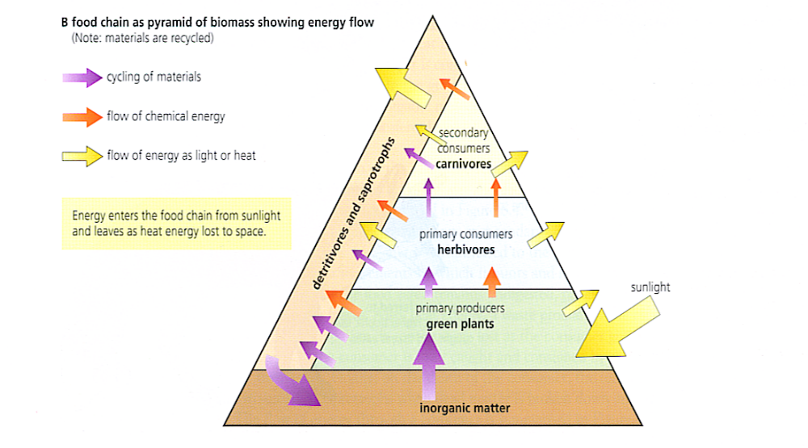
One of the problems with pyramids of biomass is they measure the matter in different organisms at that point. It does not allow for matter being added (births, growth) or for matter consumed. The preferred pyramid is a pyramid of energy that looks at the inflow of energy in each trophic level.

A pyramid of energy will never be inverted since it looks at figures of the amount of energy per unit area (or volume) that flows through the trophic level in a given period of time. There are a few examples of the pyramid, but they destroy the observed organism and the data is hard to obtain. They still provide the most accurate tool to analyze an ecosystem based upon the populations of organisms.
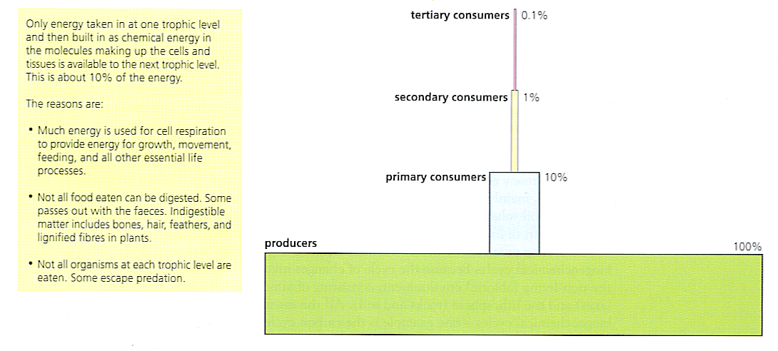

Pyramids of biomass can be converted to pyramids of energy. The amounts of energy are converted into kJ (kilojoules) and are measured in square meters or area occupied by the community per year. (kJ m⁻² year⁻¹).

Interfering with Pyramids

Most ecosystems can adapt to small changes, for example, the changing of the seasons. Large changes can permanently alter the types and size of a population found in the ecosystem.

Factors are:

- Hunting and fishing

- Monocultures – where diversity becomes limited and ecosystems become less stable. An example would be our reliance on only certain species of plants (softwood) has a negative impact. This is why Biodiversity is very important.

- Pesticides – by wiping out a member of a food chain, we may disrupt the entire ecosystem. Another issue is biological amplification, where pesticides go through a food chain and build up in the top of the food chain with tertiary consumers. Due to the need for more biomass, the toxic build up in top predators is great. (Peregrine Falcon)

Analyzing Communities (not part of, but important)

After looking at a community, we can see the very intricate ways in which animals relate to one another. Every animal has its own habitat, or physical space to live, as well as a niche, or a role to play in that community.

As a community ages, the organisms and the niches they occupy tend to change. This is called succession.

In a new community, pioneer organisms (weeds, grasses, etc.) move in first, helping to regenerate the soil, lowering the soil temperature and the amount of moisture evaporation. These plants are sun tolerant and resist fluctuations in soil temperatures.

The pioneer community is pushed out by a seral community whose species are similar to the pioneers but have a longer life cycle. These plants stabilize and enrich the soil, but crowd out the annual and biennial plants.

A second seral community then follows. These are tree that grow rapidly and require more nutrients and water than shrubs from the previous community. The shade caused by these trees cause shrubs to die and prevents the growth of saplings.

Finally a climax community forms. These are trees that tolerate shade and have a high rate of sapling survival. They work to stabilize the environment, and stay in place until a major event takes place, bringing the community back to pioneer status.

Give an example of succession after a major event.

The majority of communities described so far are climax communities. However, change is very important for the maintenance of diversity. In the pioneer community, diversity is the largest and in the climax community where biodiversity is in decline.

Generalizations about succession:

- Species composition changes more rapidly during the earlier stages of succession
- The total number of species increases dramatically during the early stages of succession, begins to level off during intermediary phases, and usually declines as the climax community becomes established.
- Food webs become more complex and the relationships more clearly defined as succession proceeds.
- Total biomass and non-living organic matter increase during succession and begin to level off during the establishment of the climax community.

